 | 7.3.15 Editors - 3D Viewport - Sidebar - Tool Tab - Grease Pencil - Layer Panel
Table of content
Layer Panel 2
Layer list 2
Layer name 2
Grease pencil layers right click menu 3
Edit Source 3
Reset Panel Zoom 3
Delete Group 3
Ungroup 3
Merge Group 3
Colors 3
Mask Layer 3
Onion Skinning 3
Viewport/Render Visibility 3
Lock 3
Search Field 3
Add new layer 4
Add New Layer Group 4
Remove Layer Group 4
Add Extra menu 4
Add Group 4
Delete Group 4
Ungroup 4
Move To Top 4
Move To Bottom 4
Duplicate Layer 4
Duplicate Empty Keyframes 4
Show All 4
Hide Others 5
Lock All 5
Unlock All 5
Merge Down 5
Merge All 5
Mask with Layer Above 5
Mask with Layer Below 5
Copy Layer to Selected 5
Copy all Layers to Selected 5
Reorder Layer 5
Isolate Layers 5
Isolate layers 5
Autolock Inactive layers 6
Ignore Material Locking 6
Blend Mode 6
Opacity 6
Lights 6

Layer Panel

The content of the Tool tab in the sidebar and the tool settings above the 3D view is usually equal. The Layer panel is a special panel in this regards. It just exists in the tool settings above the 3Dview. And it exists in all grease pencil modes but the object mode.
Grease Pencil objects each have a list of 2D layers for grouping and arranging strokes in a List view. Any stroke can only belong to a single 2D layer. There is always only one active layer in the list (the selected one). When you draw, the new strokes are added to the active layer. By default the view order of the layers in the viewport is top to bottom.
Every layer correspond to a channel in the Dope Sheet editor (in Grease Pencil mode). Layers can also be used together with Modifiers to only affects part of your drawing.
The content is the same than in the Properties editor in the Object Data Properties for a grease pencil object.
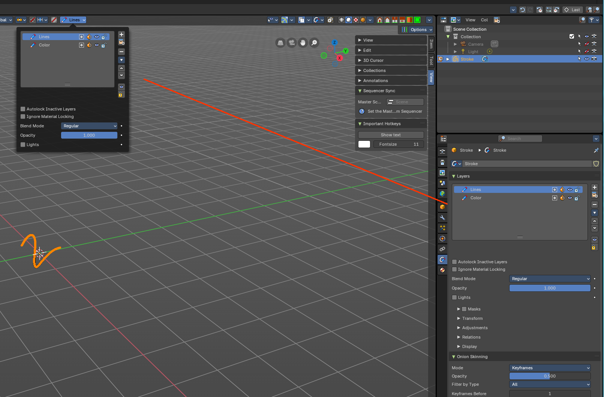

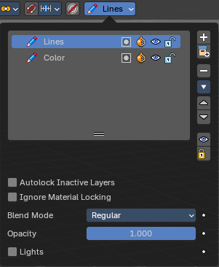

Layer list

Layer name
The name of the layer.

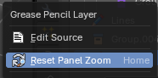
Grease pencil layers right click menu
A right click at a group in the list reveals a menu with further options.
When you click at a group layer, then you will reveal further options.

Edit Source
Allows you to edit the source code.

Reset Panel Zoom
Resets the zoom of the panel to the default value. Note that this entry is dysfunctional. You cannot zoom the panel.

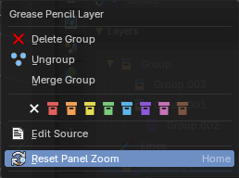
Delete Group
Deletes the selected group. It does not keep the children, and deletes the whole hierarchy.

Ungroup
Ungroups the selected group.

Merge Group
Combine the layers in this group into a single layer.

Colors
Allows you to color your layer groups in the list. It does not show

Mask Layer
Toggle the Masks visibility in the layer.

Onion Skinning
Toggle the use the layer for Onion Skinning.

Viewport/Render Visibility
Toggle layer visibility in the viewport and in render.

Lock
Toggle layer from being editable.

Search Field
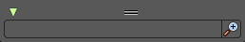
You can expand a search field at the bottom of the list. Type in your term and hit enter to filter for your term.

Add new layer
Adds a new layer.

Add New Layer Group
Adds a group. You can then drag n drop layers into it.

Remove Layer Group
Deletes the selected group. But keeps the children, and the hierarchy.

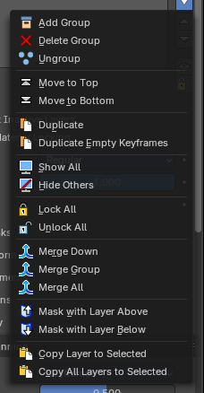
Add Extra menu

Add Group
Adds a group. You can then drag n drop layers into it. The group will be added as a child when you have a group selected.

Delete Group
Deletes the selected group.

Ungroup
Ungroups the selected group.

Move To Top
Moves the active selected grease pencil layer to top

Move To Bottom
Moves the active selected grease pencil layer to bottom

Duplicate Layer
Makes an exact copy of the selected layer appending a number to differentiate its name. This method does not duplicate empty keyframes.

Duplicate Empty Keyframes
Makes an exact copy of the selected layer appending a number to differentiate its name. This method does duplicate empty keyframes.

Show All
Turns on the visibility of every layer in the list.

Hide Others
Turns off the visibility of every layer in the list except the active one.

Lock All
Locks edition of all the layers in the list

Unlock All
Unlocks edition of all the layers in the list.

Merge Down
Merge the selected layer with the layer below. The new layer keeps the name of the lower layer.

Merge All
Merge the selected layer with all layers. The new layer keeps the name of the active layer.

Mask with Layer Above
Mask the active layer with the layer above.

Mask with Layer Below
Mask the active layer with the layer below

Copy Layer to Selected
Appends the active layer to the selected object.

Copy all Layers to Selected
Appends all layers to the selected object.

Reorder Layer
Move the selected layer up or down in the list.

Isolate Layers
Locks and hides all not active layers.

Isolate layers
Locks all not active layers.

Autolock Inactive layers
Automatically lock all layers except the active one to avoid accidental changes

Ignore Material Locking
Allow editing strokes even if they use locked materials.

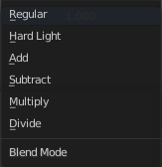
Blend Mode
The layer blending operation to perform. See Color Blend Modes.

Opacity
Used to set the opacity of the layer.

Lights
When enabled, the layer is affected by lights.

